Universidad de San Carlos de Guatemala

Centro Universitario de Occidente

Ingeniería en Sistemas

Lenguajes Formales de Programación

Edwin Osvaldo Tax Turnil 201730482

AFD Practica 1

6/10/2021

Token: Letras

E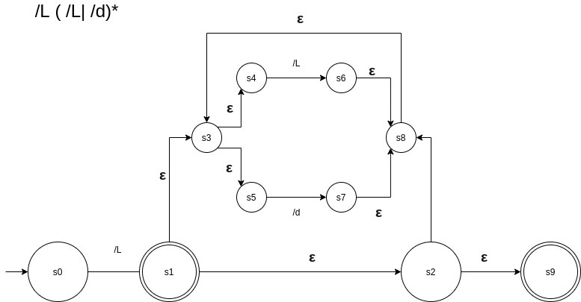xpresión Regular Y Autómata Finito No Determinista

Tabla de Transición

|  |  |  |  |
| --- | --- | --- | --- |
| FT función de transición | ε | / l | / d |
| S0 | q0 = **{ }** | ∂(A,a) = s1 | ∂(A,b) = { } |
| S1 | q1 = s2,s3,s4,s5,s9 | ∂(B,a) = s6 | ∂(B,b) = s7 |
| S6,s7 | q2 = s2,s3,**s4**,**s5**,s8,s9 | ∂(C,a) = s6 | ∂(C,b) = s7 |

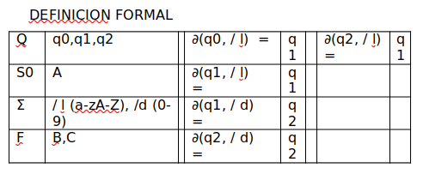

OPTIMIZACIÓN

|  |  |  |
| --- | --- | --- |
|  | / l | / d |
| q0 | B |  |
| q1 | B | C |
| q2 | B | C |

A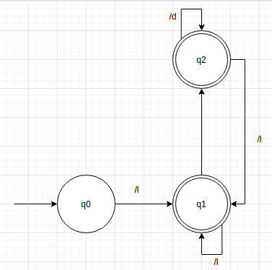utómata Finito Determinista

Token: Números/Dígitos

Expresión Regular Y Autómata Finito No Determinista

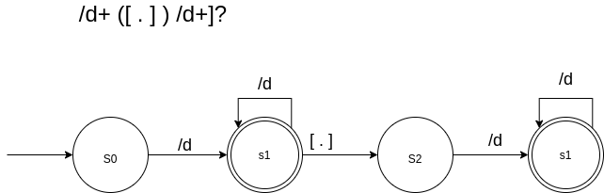TABLA DE TRANSICIÓN

|  |  |  |
| --- | --- | --- |
| FT función de transición | / d | [ . ] |
| S0 | ∂(A,/d) = s1 | ∂(q0, [.]) = s2 |
| S1,s2 | ∂(B,/d) = s1,s3 | ∂(q1, [.]) = s2 |
| S3 | ∂(C,/d) = s3 | ∂(q2, [.]) = { } |

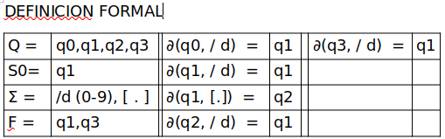OPTIMIZACIÓN

|  |  |  |
| --- | --- | --- |
|  | / d | [ . ] |
| q0 | q1 |  |
| q1 | q1 | q2 |
| q2 | q1 |  |
| q3 | q1 |  |

AUTOMATA FINITO DETERMINISTA

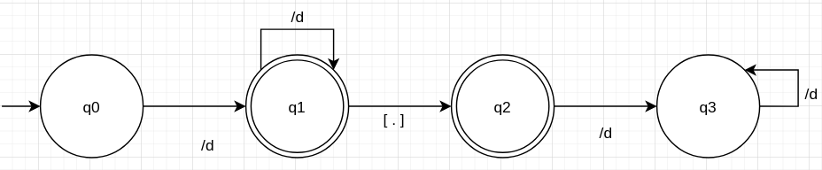

Token: Puntuación

Expresión Regular Y Autómata Finito No Determinista

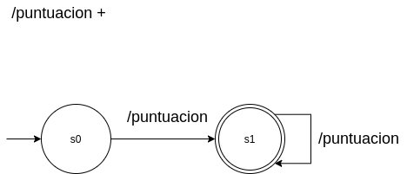

OPTIMIZACION DEFINICION FORMAL

|  |  |  |
| --- | --- | --- |
|  | / punt |  |
| q0 | q1 |  |
| q1 | q1 |  |

|  |  |  |  |  |
| --- | --- | --- | --- | --- |
| Q = | q0,q1 |  | ∂(q0, /puntuacion) = | q1 |
| S0 = | q0 |  | ∂(q0, /puntuacion) = | q1 |
| Σ = | [ . ] [ , ] [ : ] [ ; ] |  |  |  |
| F = | q1 |  |  |  |

Token: Operador

Expresión Regular Y Autómata Finito No Determinista

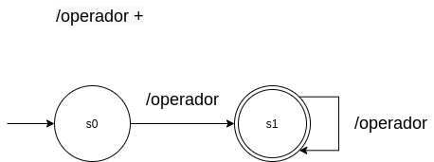

OPTIMIZACION DEFINICION FORMAL

|  |  |  |
| --- | --- | --- |
|  | / punt |  |
| q0 | q1 |  |
| q1 | q1 |  |

|  |  |  |  |  |
| --- | --- | --- | --- | --- |
| Q = | q0,q1 |  | ∂(q0, /operador) = | q1 |
| S0 = | q0 |  | ∂(q0, /operador) = | q1 |
| Σ = | [ + ] [ - ] [ * ] [ / ] [ % ] |  |  |  |
| F = | q1 |  |  |  |

Token: Agrupacion

Expresión Regular Y Autómata Finito No Determinista

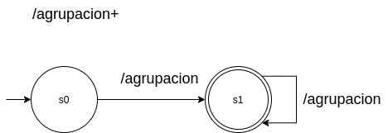

OPTIMIZACION DEFINICION FORMAL

|  |  |  |
| --- | --- | --- |
|  | / punt |  |
| q0 | q1 |  |
| q1 | q1 |  |

|  |  |  |  |  |
| --- | --- | --- | --- | --- |
| Q = | q0,q1 |  | ∂(q0, /agrupacion) = | q1 |
| S0 = | q0 |  | ∂(q0, /agrupacion) = | q1 |
| Σ = | ‘(’ ,‘)’,’[’,’]’,’{’,’}’ |  |  |  |
| F = | q1 |  |  |  |

Autómata General

